Exercise

1:- Create html form and with one file field and one submit button and print $_
FILES array after submit the form.
Answer :
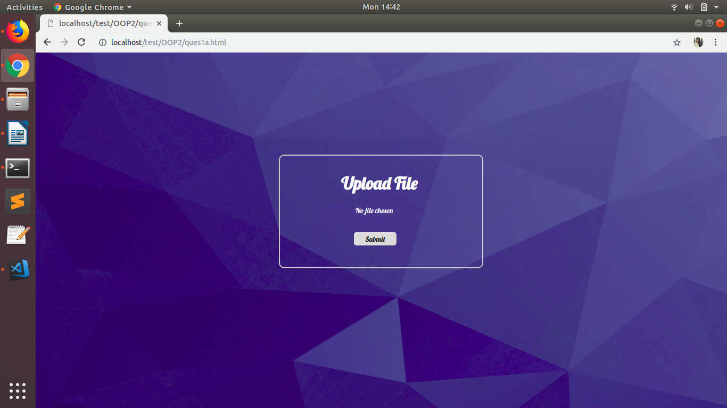
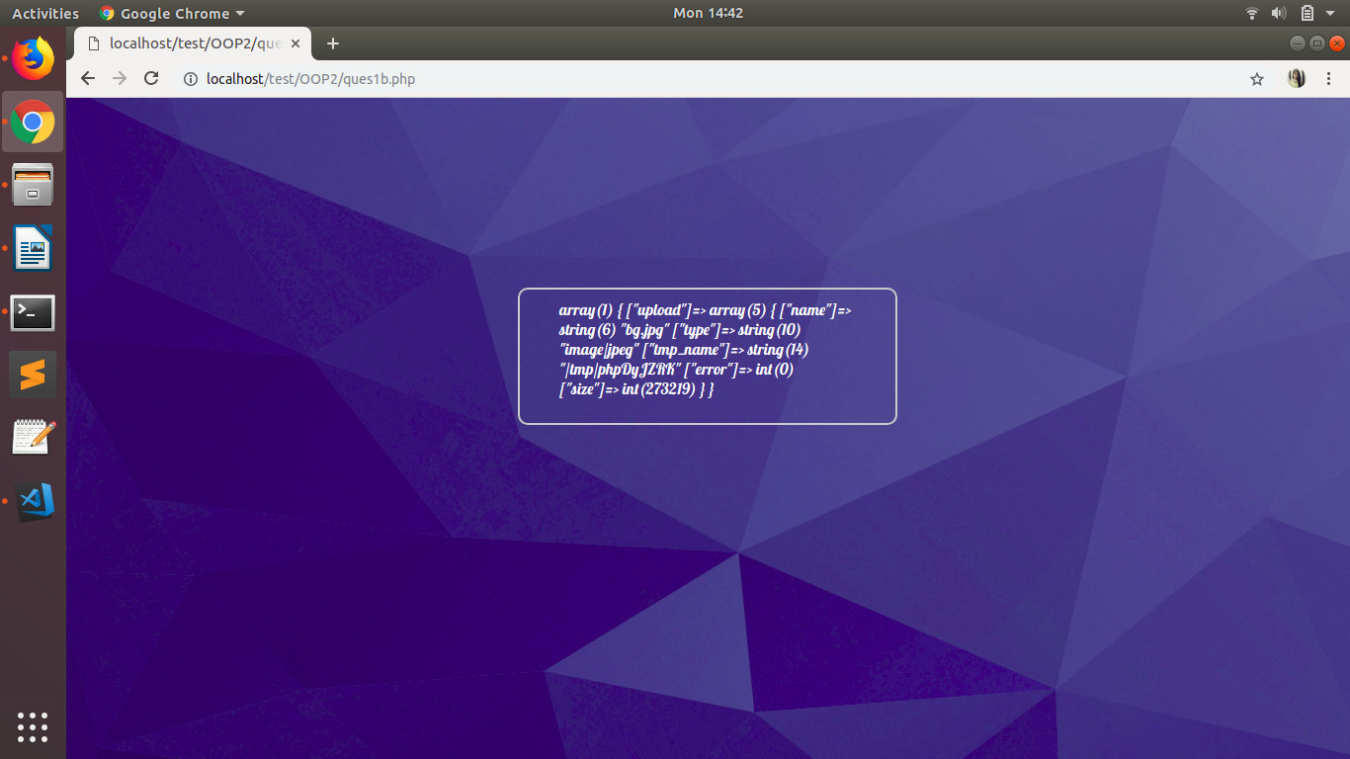
2:- Create php program to set value in cookies and get it by $_COOKIE.
Answer:
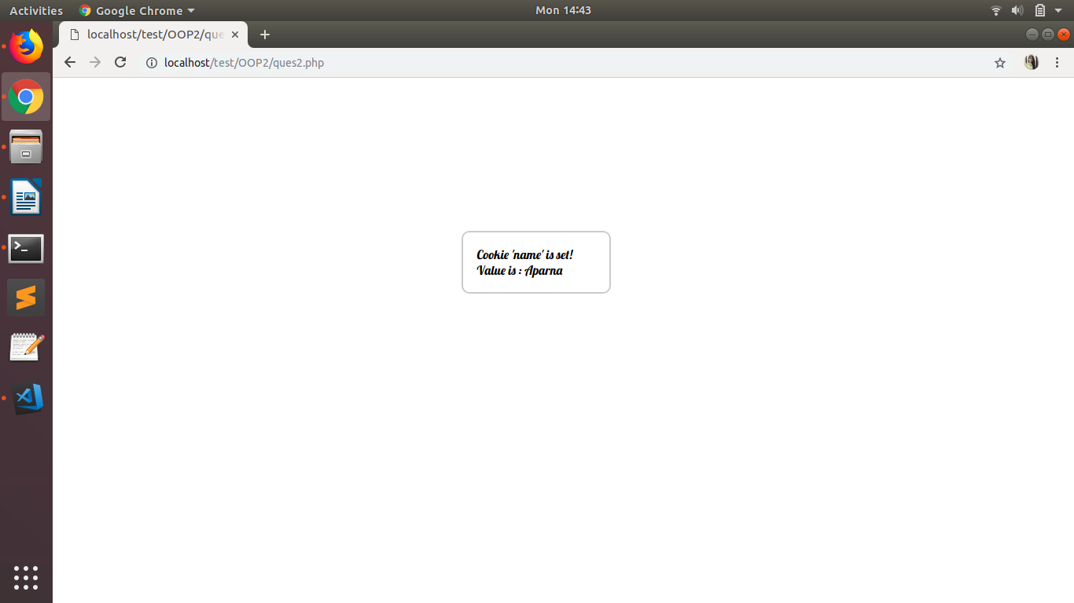
3.- Develop prototype for flight-booking service. Here, we don't own any flights. we are just a service provider mediator.
Define two methods :
a. checkFlightsAvailability() - to check available flights from two vendors like "Air India", "IndiGO".
b. bookFlights() - to book a seat from respective vendor.
Answer : Database
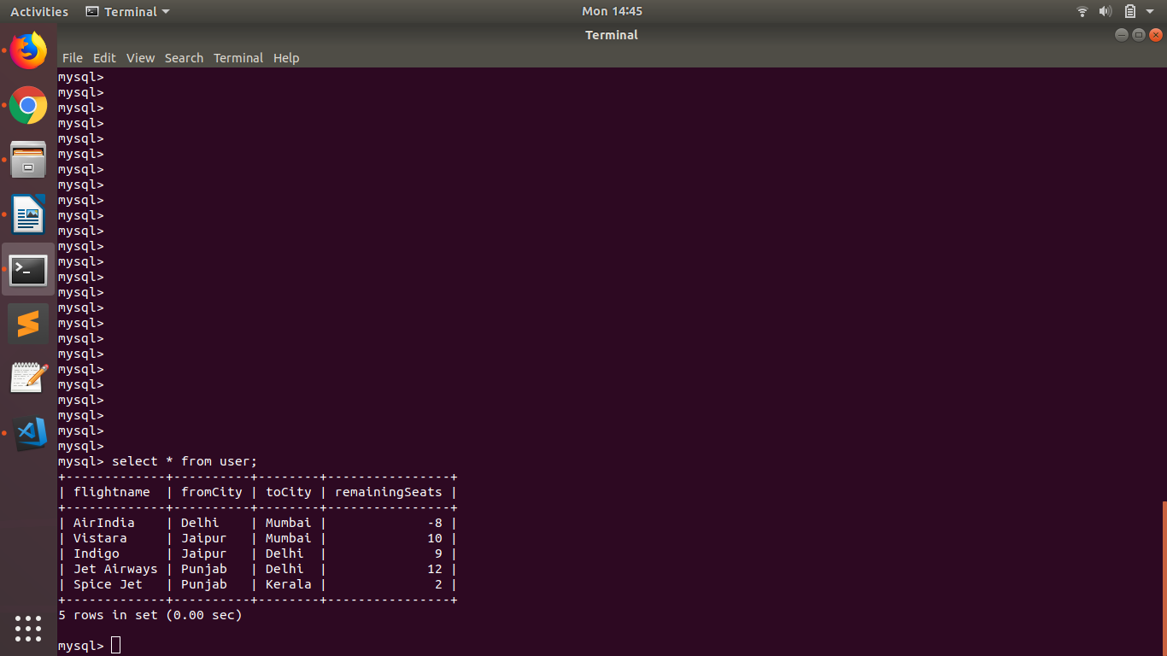
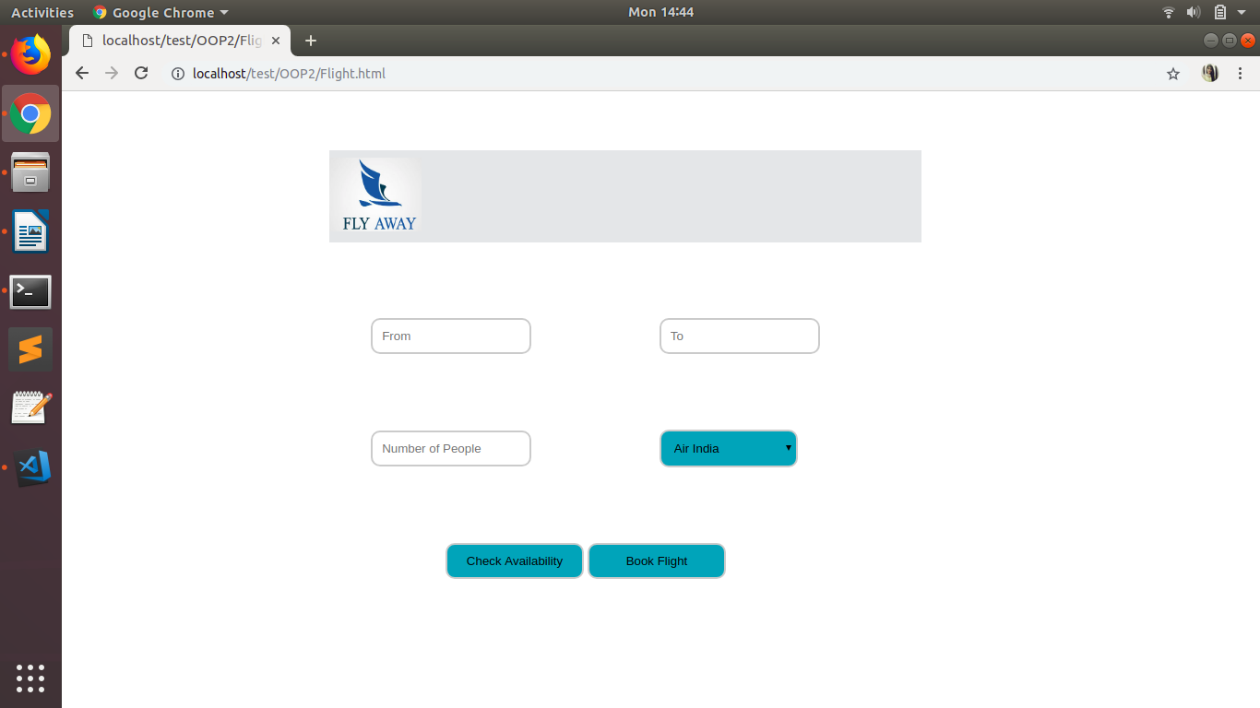
Form :

4:- Define three traits and use it in class and override it's function.
Answer :
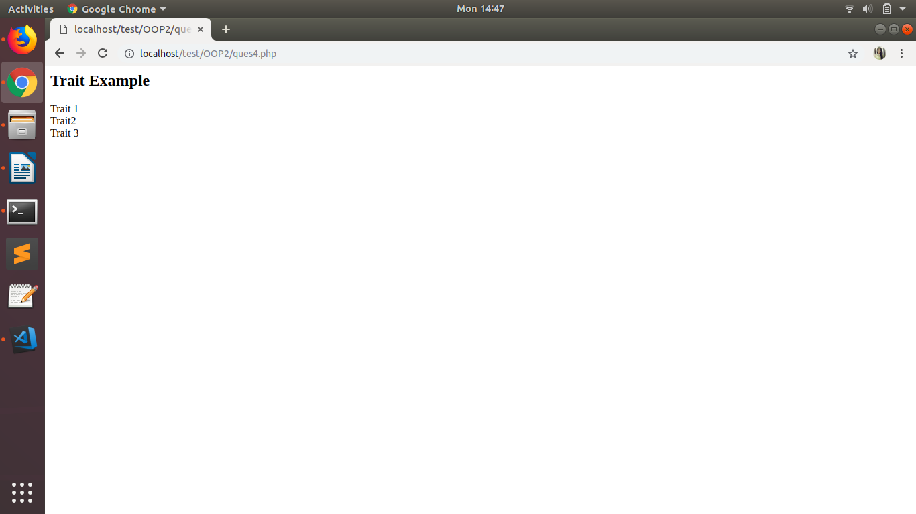

5:- Write a program to check existence of a file and throw exception if file does not exists.
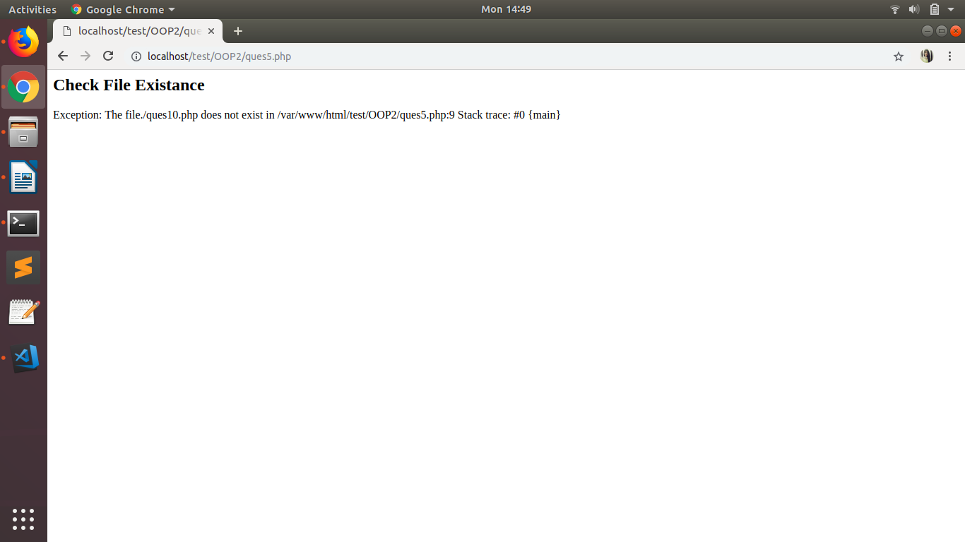
Answer :

